מחשוב ענן – פרויקט סוף

**שם קבוצה:** Zebra

**קישור למחברת Colab:**

<https://colab.research.google.com/drive/1nAKxOCsUVoGf6NYYv49A85g5X0ja8X2Y#scrollTo=tXIDXEwEE2dC>

**קישור לגיט:**

<https://github.com/audiblemaple/collab_test>

**קישור למסד הנתונים:**

<https://newproj-b2090-default-rtdb.europe-west1.firebasedatabase.app>

חברי הקבוצה:

|  |  |
| --- | --- |
| גלעד סגל | 314865841 - QA |
| כפיר חמו | 318262151 - Scrum Master |
| ניצן ממן | 205798515 - UI |
| רון שחר | 206755712 - Backend Developer |
| דניאל ורדימון | 209289685 - Product Manager |
| ליאור ז׳יגלו | 316109115 - Frontend Developer |

**תוכן עניינים:**

1. תיאור המערכת ------------------------------------ עמוד 1

2. דרישות פונקציונליות ולא פונקציונליות ----------- עמוד 2-3

3. USECASE ---------------------------------------- עמוד 3

4. איטרציות עבודה ------------------------------------ עמוד 4-6

5. ציון ה-SUS ----------------------------------------- עמוד 6

6. תיק מתכנת ----------------------------------------- עמוד 7-11

7. תיק משתמש --------------------------------------- עמוד 12-27

8. אתגרים במהלך הפרויקט -------------------------- עמוד 28

1. **תיאור המערכת**

**המערכת שבחרנו לתכנן היא AdventureCloud**

"AdventureCloud" הוא משחק אינטרקטיבי במהלכו השחקנים מצטרפים למסע מהנה ומלמד בממלכת קלאודטופיה (Cloudtopia). השחקנים מתקדמים במשחק על ידי הצגת ידע מעמיק בתחומי מחשוב ענן. רעיון המשחק הוא סוג של מסע חיפוש (quest) להצלת הממלכה כאשר הקריטריון אשר משמש להצלחה הוא ידע מעמיק במחשוב ענן.

השחקנים מתחילים במשימות בסיסיות של היכרות עם מושגים בסיסיים במחשוב ענן, כמו אחסון בענן וחיבורים לרשת. ככל שהם מתקדמים במשחק, המשימות מסתובבות סביב פתרון בעיות מתקדמות יותר, יישום של שירותים מתקדמים בענן כמו חישוב בענן, אבטחת מידע ופתרון תקלות, וגישה לניהול המשולב של המחשוב הענן.

במהלך המשחק, השחקנים יכולים להשתמש ביכולות ובידע שצברו כדי לפתור פאזלים ולהילחם בבוסים ברמות שונות. כמו כן, הם יכולים לשתף פעולה עם שחקנים אחרים, להתחרות בהם או ליצור קבוצות עבור משימות משותפות.

1. **דרישות פונקציונליות ולא פונקציונליות**

דרישות לא פונקציונליות (NFR) + סיווג

1. מספר רב של שחקנים יוכלו להשתמש במערכת בו זמנית מבלי לחוות פיגור או האטות.

ביצוע (Performance)

1. משתמש יידרש להכניס שם משתמש וסיסמא בכדי להתחבר למשחק.

בטיחות (Security)

1. מפתחי המערכת מסוגלים לדאוג לאמינות גבוהה של המשחק - מינימום זמן השבתה או קריסות.

אמינות (Reliability)

1. משתמשים יוכלו להתחבר למשחק דרך מגוון מכשירים, מערכות הפעלה וסוגים של דפדפני אינטרנט.

תאימות (Compatibility)

1. מפתחי המערכת יהיו מסוגלים לשנות את התשתית והמשאבים של המשחק כדי לעמוד בדרישות של התרחבות בסיס שחקנים.

מדרגיות (Scalability)

דרישות פונקציונליות (FR):

1. המערכת חייבת לאפשר למשתמשים ליצור ולנהל את החשבונות שלהם, כולל שמות משתמש, סיסמאות ופרטי פרופיל.
2. המערכת תאפשר הצגת קטעי הדרכה שיספקו למידה של היסודות של מחשוב ענן והבנה כיצד לשחק במשחק.
3. המערכת חייבת לכלול מגוון משימות ובדרגות קושי שונות. בנוסף, המערכת תעניק פרסים (תגמולים) שונים.
4. המערכת תאפשר לשחקנים לחבור לשחקנים אחרים כדי לפתור חידות ולהילחם בבוסים בקבוצות.
5. המערכת תאפשר לעקוב אחר התקדמות המשתמשים ולספק משוב על הביצועים שלהם, כגון נקודות, רמות והישגים.
6. **תרשים USECASE**

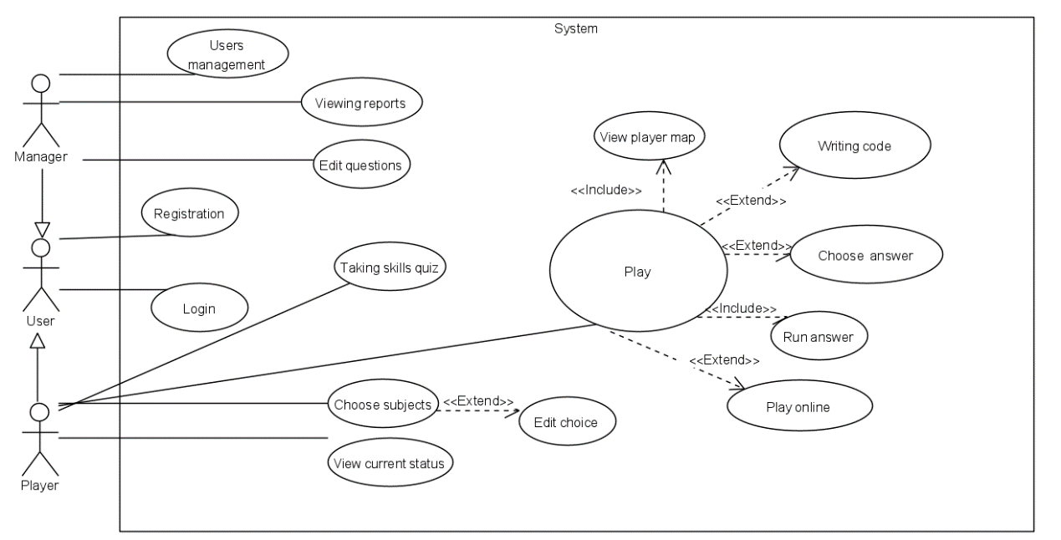

1. **איטרציות עבודה**

|  |  |  |  |
| --- | --- | --- | --- |
| Executor | Task | Requirement | Iteration |
|  |  |  | Iteration 1 |
| Product Manager - Daniel | Tracking and monitoring progress | The Product Manager is responsible for constructing project requirements |  |
| UI developer - Nitsan  Frontend Developer - Lior | Question screen logic | The system will present multiple choice questions and allow choosing one answer. |  |
| Backend Developer - Ron | Building DB - structure and content | The DB will include users' data and questions data. |  |
| Backend Developer - Ron | Building DB - structure and content | The questions will be in 4 different main topics: Python, DevOps, JSON and XML. |  |
| Backend Developer - Ron | Building DB - structure and content | The questions will be assigned level of difficulty. |  |
| Backend Developer - Ron | Creating login screen logic | The system will allow login for each player before playing the game. |  |
| UI developer - Nitsan  Frontend Developer – Lior | Creating quiz menu logic – 4 sub-topics | When new game option has been chosen, the player will choose one topic out of the 4 main topics for the quiz. |  |
| UI developer - Nitsan  Frontend Developer – Lior | Creating quiz menu logic | The player could decide on amount of question for his quiz. |  |
| UI developer - Nitsan  Frontend Developer - Lior | Creating question screen logic | The system will present appropriate message for the user after he chose an answer. |  |
| UI developer - Nitsan  Frontend Developer – Lior | Creating question screen logic | The system will present the player's progress (amount of correct and incorrect answers) while he moves from one question to the next. |  |
| Backend Developer – Ron  Frontend Developer – Lior | Creating admin's home screen logic  Creating admin's manager tool | The admin home screen will allow him to add info to the DB. |  |
| UI developer - Nitsan  Frontend Developer – Lior | Creating player's home screen logic | The player home screen will allow him to start a new quiz or view his best score. |  |
| Backend Developer – Ron | Building DB - structure and content | The system will support two types of users: players and managers. |  |
| QA – Gilad  Product Manager – Daniel | Writing acceptance tests | The QA Manager oversees the planning and execution of testing activities. |  |
| Scrum Master – Kfir  Product Manager – Daniel | Facilitate scrum events | The Scrum Master will be responsible on the team's scrum events. |  |
|  |  |  | Iteration 2 |
| UI developer - Nitsan  Frontend Developer – Lior | Creating admin's home screen UI | Creating appropriate UI for the Admin operations: add questions, update questions and erase questions. |  |
| Backend Developer - Ron | Creating login DB for players | Creating DB for the players personal info and login info. |  |
| Backend Developer - Ron | Creating games scores DB for players | Saving each player's scores in the DB. |  |
| Frontend Developer – Lior | Creating games scores DB for players  Creating quiz summary logic + UI | Presenting the player's total scores from his entire game history as summery graph. |  |
| Scrum Master – Kfir | Reporting and documentation | Creating programmer documentation: main file names, main functions, important design patterns. |  |
| QA – Gilad | Reporting and documentation | Creating user documentation: general explanation about the game, his features, main screens, different configurations (Admin and Player) and possible errors. |  |
| Product Manager – Daniel | Marketing | Creating marketing video that depicts the game and how to play it. |  |
| Frontend Developer – Lior | Team development and guidance | Updating and improving existing features after Interactive Studio in class. |  |
| QA – Gilad | Team development and guidance | Calculating SUS score from existing feedback (from Interactive Studio). |  |
| UI developer – Nitsan  Frontend Developer – Lior | Creating login screen UI  Creating admin's home screen UI  Creating quiz menu UI for each topic  Creating quiz summary logic + UI | Each screen in the system will include specific operations with clear writing with proper colors. |  |
| Scrum Master – Kfir  Frontend Developer – Lior | Tracking and monitoring progress | The total frontend of the system will be in unique and uniform design. |  |
| Scrum Master – Kfir  Product Manager – Daniel | Team Development and guidance | The scrum master will help remove obstacles, in manner of coding and project structure. |  |
| Product Manager – Daniel | Tracking and monitoring progress | The product manager will define objectives and timelines. |  |
| Scrum Master – Kfir  Frontend Developer – Lior | Creating quiz summary logic + UI | After each quiz the system will present a summary chart with the player's performance. |  |
| QA – Gilad | QA and Acceptence Tests | The QA Manager will continue to evaluate and improve the quality assurance process of the project. |  |
| Product Manager – Daniel | Reporting and documentation | During the duration of the project, the Project Manager prepares status reports, documentation, and other project-related products. |  |
| QA – Gilad | QA and Acceptence Tests | Writing acceptance tests. |  |

1. **חישוב ציון ה-SUS**

חישוב ציון ה-SUS:

87.61 (לפי טבלת האקסל המצורפת במטלה 3 חלק א)

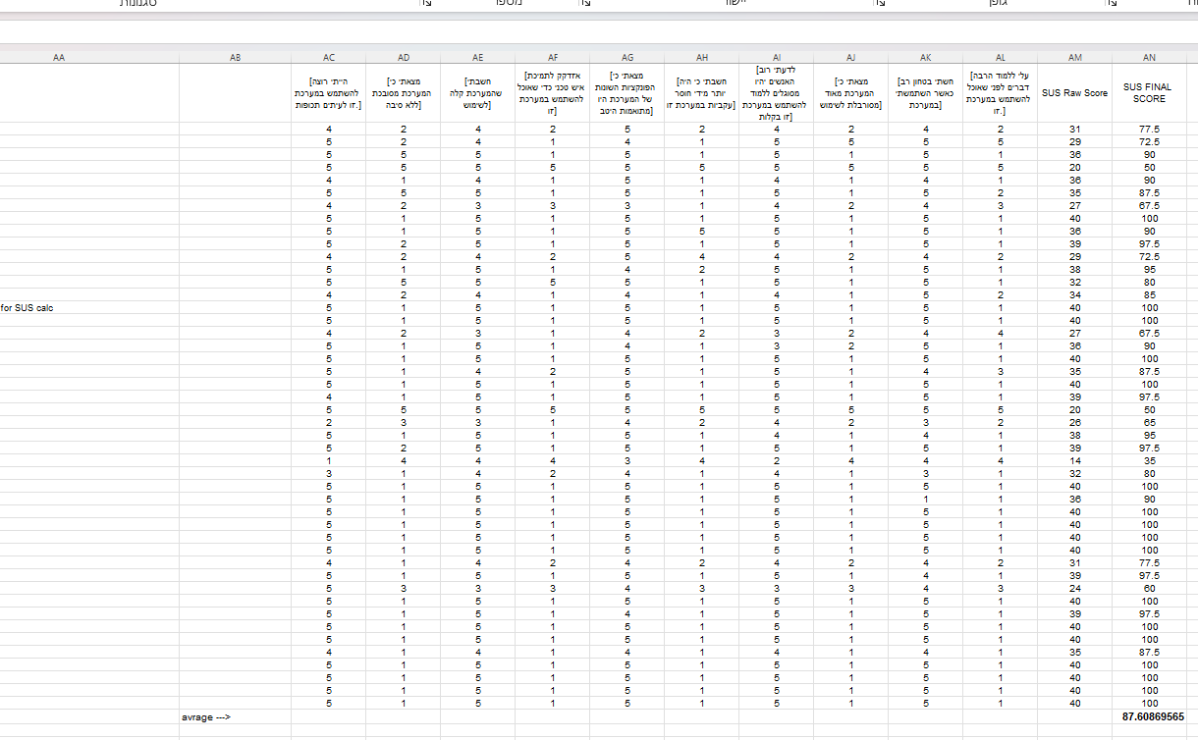

1. **תיק מתכנת**

**Imports:**  
import json  
import pdb  
import time  
import uuid  
import html  
import time  
import uuid  
import base64  
import IPython  
import random  
import threading  
from PIL import Image  
from io import BytesIO  
from firebase import firebase  
from google.colab import output  
import plotly.graph_objects as go  
from IPython.display import display  
from IPython.display import display, HTML  
from numpy.matrixlib.defmatrix import matrix  
from IPython.display import display, HTML, Javascript

**Classes:**

InvokeButtonWithPlace(title, callback, source, wSize, hSize, tPos, lPos):   
Creates an html button with a predefined style and a given image.  
title: sets the text inside the button (deprecated but still functional).  
callback: name of a python function to call.  
source: URL to an image for the background.  
wSize: width of the button.  
hSize: height of the button.  
tPos: distance from top of the screen.  
lPos: distance from the left of the screen.

InvokeBackground (title, callback, source):   
Creates the background element with the provided image.  
title: deprecated and should not be used  
callback: name of a python function to call (deprecated).  
source: URL to an image for the background.

InvokeBackgroundVideo (title, callback, source):   
Creates a video from a given source.  
title: sets the text inside the button (deprecated and should not be used).  
callback: name of a python function to call (deprecated).  
source: URL to a video file.

InvokeInfoBackground (title, callback, source):   
Creates a center box with an image that contains the games lore inside.  
title: deprecated and should not be used  
callback: name of a python function to call (deprecated).  
source: URL to an image for the background.

InvokeLogo (title, callback, source):  
Creates a logo image at the top left of the screen.  
title: deprecated and should not be used  
callback: name of a python function to call (deprecated).  
source: URL to a logo image for the background.

InvokeLoginWindow (title, callback, source):  
Creates a login window with a background,  
text boxes and login button at the center left of the screen.  
title: deprecated and should not be used  
callback: name of a python function to call, calls the log_user_in function.  
source: URL to an image for the background.

InvokeMapButtons (title, callback):  
creates 4 buttons on the map screen that overlay the 4 locations.  
each button gets its own background picture that corresponds to the location.  
title: deprecated and should not be used  
callback: name of a python function to call, calls the start_quiz function.

InvokeQuestion (question, option1, option2, option 3, option4, correct, question_type, callback, source, img_source):  
creates a question box which includes the question and 4 answers.  
question: question to display.  
option 1, 2, 3, 4: answer options to display.  
correct: correct answer (saved to later be passed to the eval_answer function).  
question_type: the type of the question in the specific quiz.  
callback: name of a python function to call, calls the eval_answer function.  
source: background image for the questions and answer options.  
img_source: if the question has an image then this will be the URL to it.  
 if not, then the image will not be displayed.

InvokePopUp (text, color):  
creates a pop up for a correct and incorrect answers.  
text: text of the pop up.  
color: color of the pop up, depends on the answer if its correct or not.

InvokeScore (score, progress_value):  
score: the score value.  
progress_value: number of answered questions.  
progress_statuses: saved array of answered questions.  
progress_max: maximum number of questions.  
score_element: score label.  
progress_element: progress div.  
functions:  
 display_progress:  
 displays the score label and progress bar.  
 update_score_progress:  
 updates the score label and progress bar.

**Functions:**

show_login_screen ():   
displays the login screen.  
creates a background, logo, login overlay, and exit button.

log_user_in ():  
called when the user clicks on the log in button, checks whether the user exists in the database, if not does nothing, else logs the user in, and saves a global reference to the user in the database.

show_leaderboards ():  
creates an html table that displays the leaderboards sorted in an ascending order.

show_map_screen ():  
creates background, quiz buttons, back button, info button and the credits button.

show_quiz_info ():  
displays a video before the quiz starts.

graph_builder (details):  
details: a parameter from the show_result_screen  
builds a graph according to the data collected during the quiz.  
displays for each of the 4 quiz types correct and incorrect answer count.

show_result_screen ():  
called when the quiz finishes.   
builds the graph with a background image, also updates high scores for each quiz and recalculates high score.

upload_score ():  
uploading the scores to the database if the score is a new high score.

sum_scores ():  
sums the scores of all quiz types.

query_quiz (question_list, quiz_type):   
question_list:  
quiz_type:  
assign the quiz image if there is one and create the question overlay.

question_generator(question_list):  
an iterator function for the question list.

fetch_questions ():  
function that fetches a new question using the question_generator.

Show_quiz_screen ():  
displays the quiz screen, initializes audio track for the quiz, background, score label and back button.

eval_answer (user_answer, correct_answer, question_type):   
user_answer:  
correct_answer:  
question_type:  
evaluates the chosen answer, this function is called when an answer is chosen.  
displays the pop-up message  
fetches a new question after an answer is chosen until there are no more questions.  
when there are no more questions calls show_result_screen function.

start_quiz(quiz_name):  
quiz_name: parameter for the switch case to know what quiz to start.  
starts the quiz video and displays the quiz screen after that.

click_test (param, param2):   
param, param2: can be anything.  
a two-parameter function to test that the class callbacks work (used for debugging).

info_screen ():  
creates and displays the info screen with the game’s lore.

info_screen_fromMap ():   
same as info_screen but from the map screen.

not_supported_yet ():  
prints “not supported yet” (used as a stub for functions that not yet exists)

credits_fire ():  
displays the super awesome credits video.

exit_app ():  
clears the screen and prints “App canceled”.

Database:

Question entries

Correct  
Level  
Option1  
Option2  
Option3  
Option4  
Pic  
Question  
Type

session entries  
date  
score  
topic

Question entries are the same for each quiz type.

Real time database

xml

python

json

devops

pyAmericanQuestions

users

user entries

devopsHighScore  
jsonHighScore  
pythonHighScore  
xmlHighScore  
sumHighScore  
scores  
username  
password  
isManager

1. **תיק משתמש**

**A Short Summary**

The name of our game is AdventureCloud, and it is a game during which the players join a fun and educational journey in the kingdom of Cloudtopia. The players advance in the game by displaying in-depth knowledge in the fields of cloud computing. The idea of the game is to create a quest to save the kingdom where the criteria used for success is a deep knowledge of cloud computing.

At this stage of the project, the players perform basic tasks of getting to know basic concepts in cloud computing, such as cloud storage and network connections - through trivia quizzes. The game offers four types of quizzes: Python, XML, Json, and Devops. Each quiz is designed in a different style (as a type of boss that represents the type of quiz) and include a melody to enhance the atmosphere of the quest game.

Each quiz contains 20 questions on the chosen topic where the user has four answer choices. The questions appear one after the other when the user selects a certain answer. When choosing an answer, the user receives an indicator message (regarding a correct or incorrect answer) as well as a progress bar in the quiz which marks the last question asked (green color - correct answer, red color - incorrect answer). Each correct answer add to the player's quiz score by 10 points and an incorrect answer does not affect the score at all. At the end of the quiz, the user is shown a graph summarizing his results in the current quiz.

**Screen Details for Player UI**

* Login Screen – designed with the group's logo (top left) with clear UI for username and password.

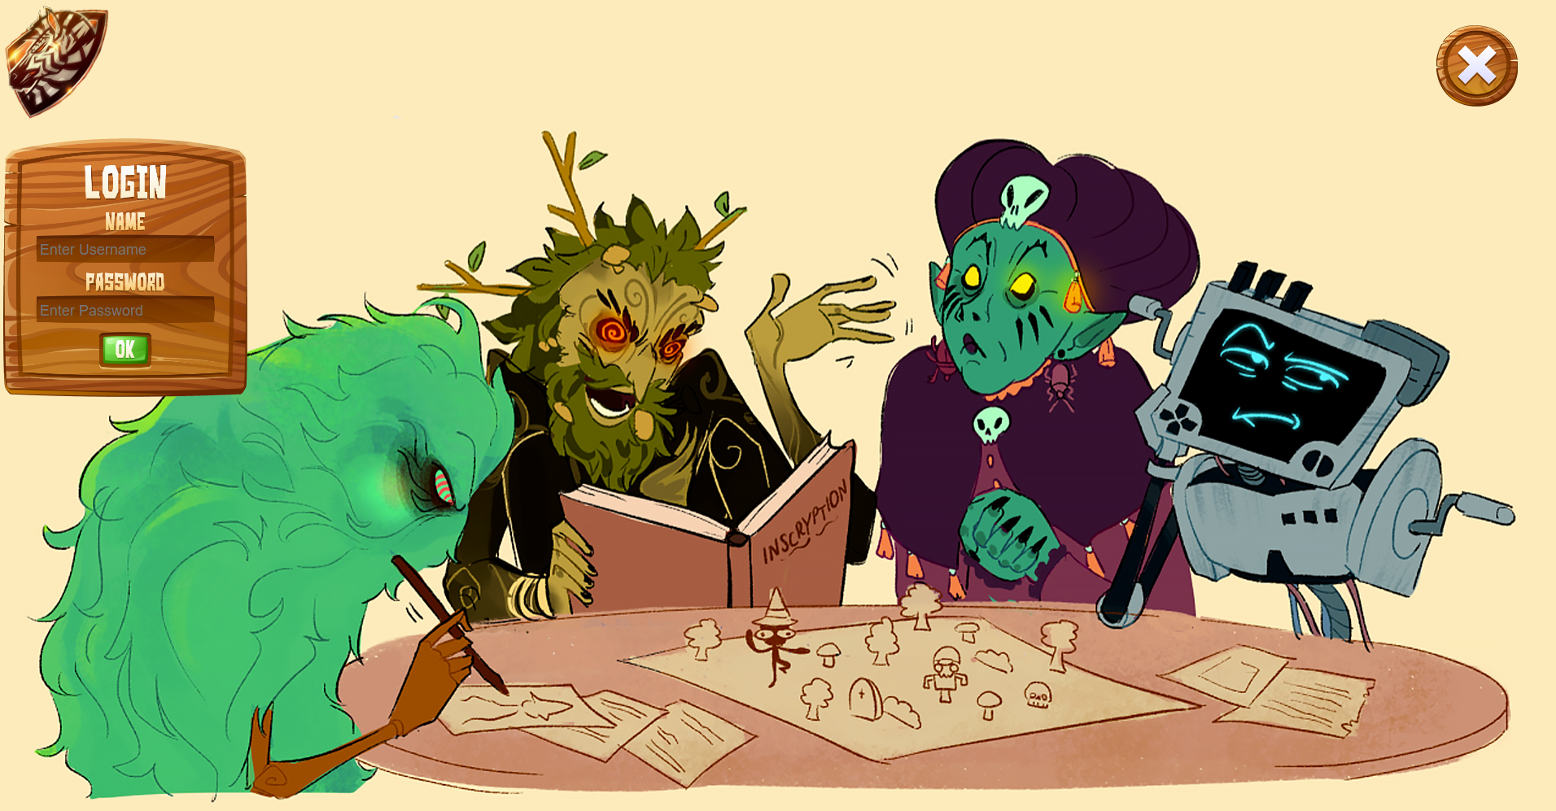

If an incorrect username and/or password is given, an error message is displayed:

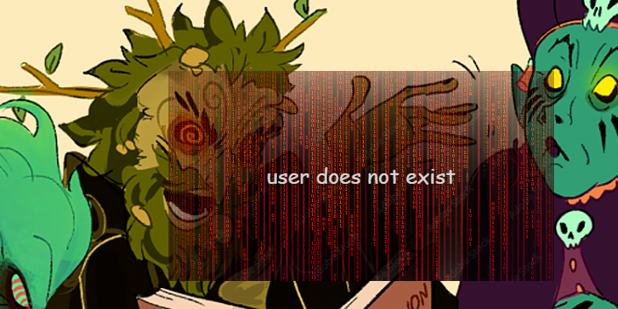

* The home screen for the player – appears after logging in. A screen that offers several options: starting a game ("Play"), a personal progress table ("My Progress"), a graph of the highest results ("High Scores"), an explanation button about the game ("?") and exiting the game ("x").

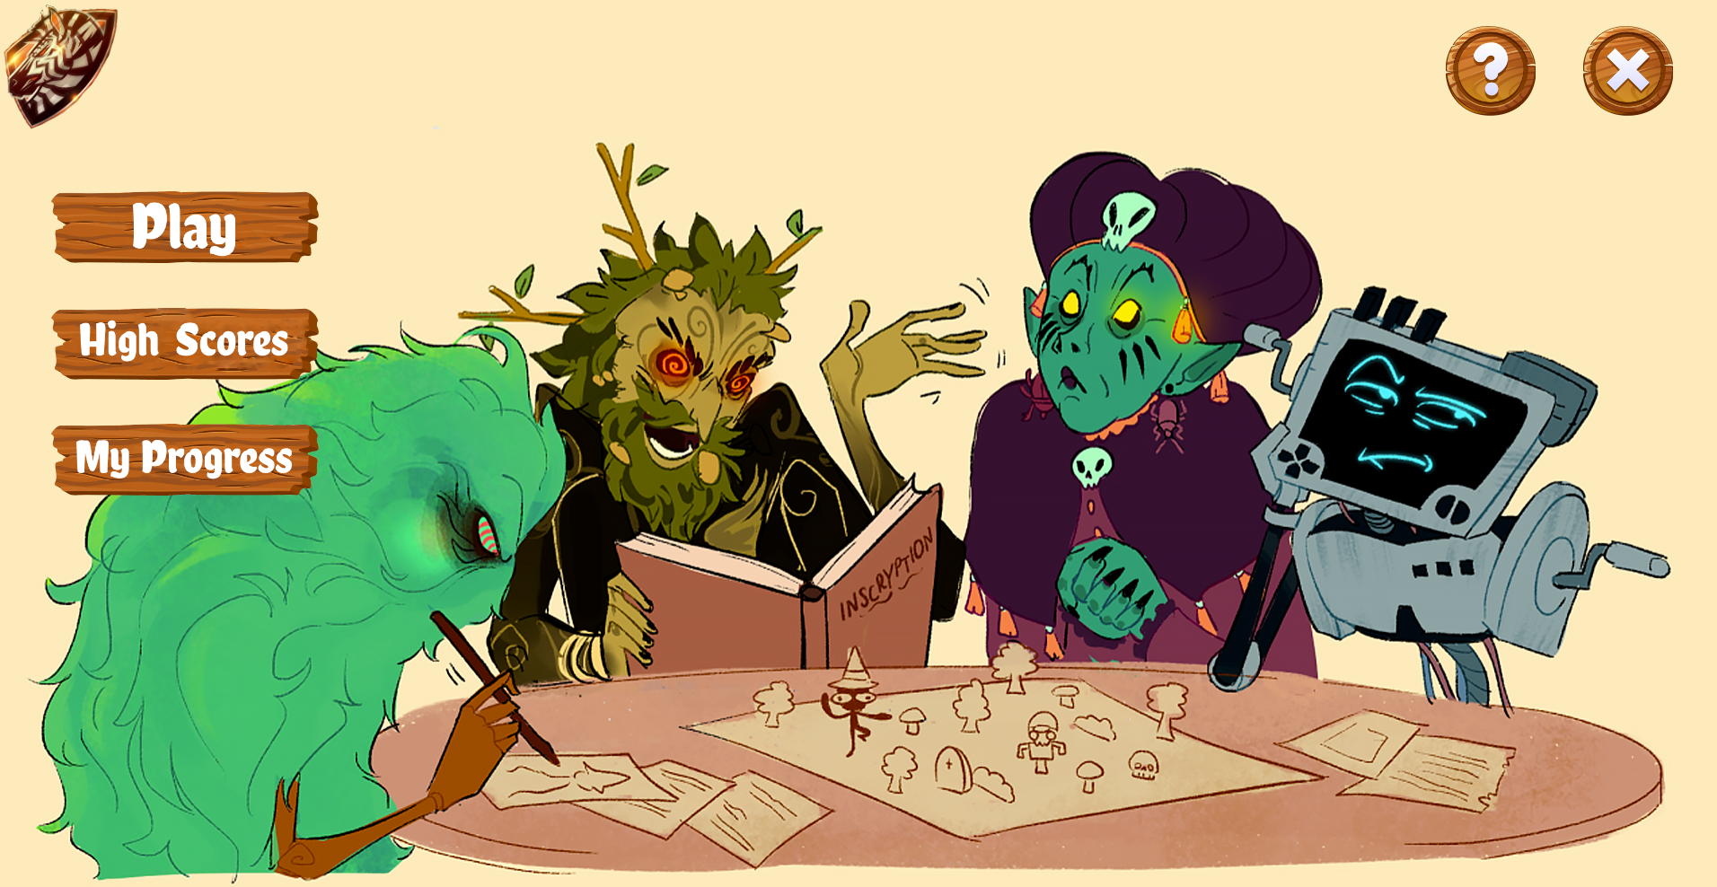

* Highest results screen - after clicking on "High Scores" a table will appear according to the names of the players registered for the game and the best result of each of them in each of the four types of quizzes. It can be closed by clicking on the "x" that belongs to it.

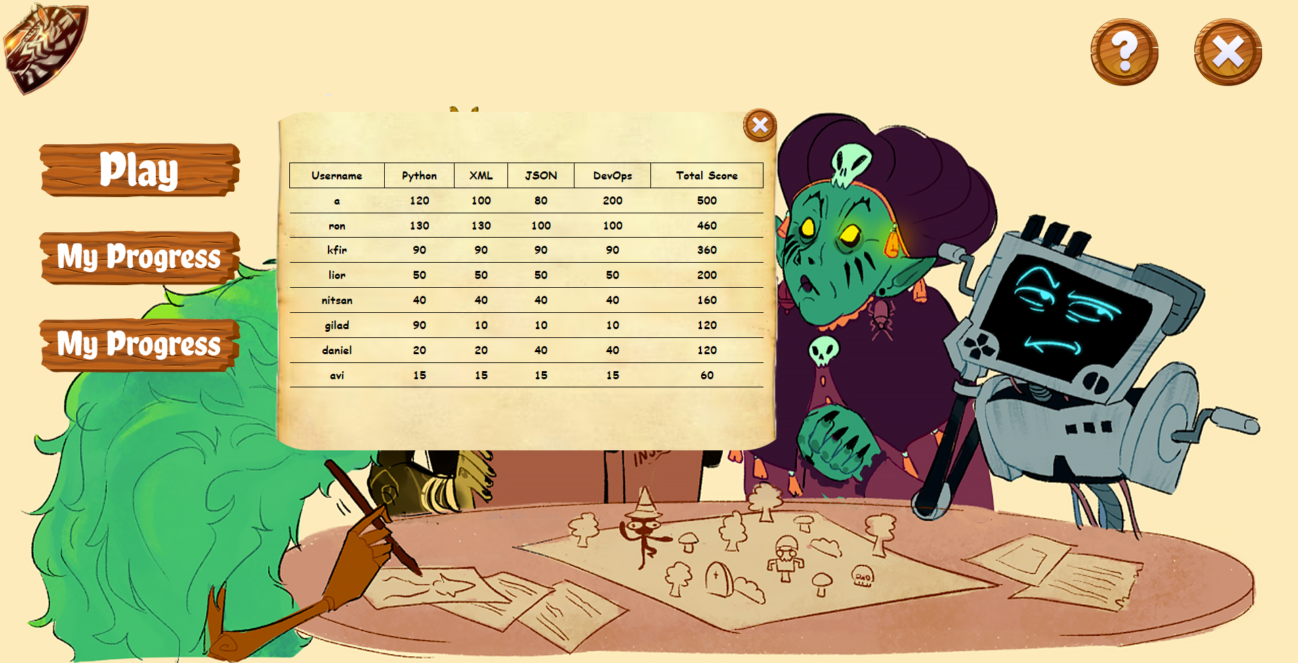

* Personal progress screen - after clicking on "My Progress" a graph will appear with the sum of the points in each of the four quizzes in the game. Clicking "x" will close the graph.

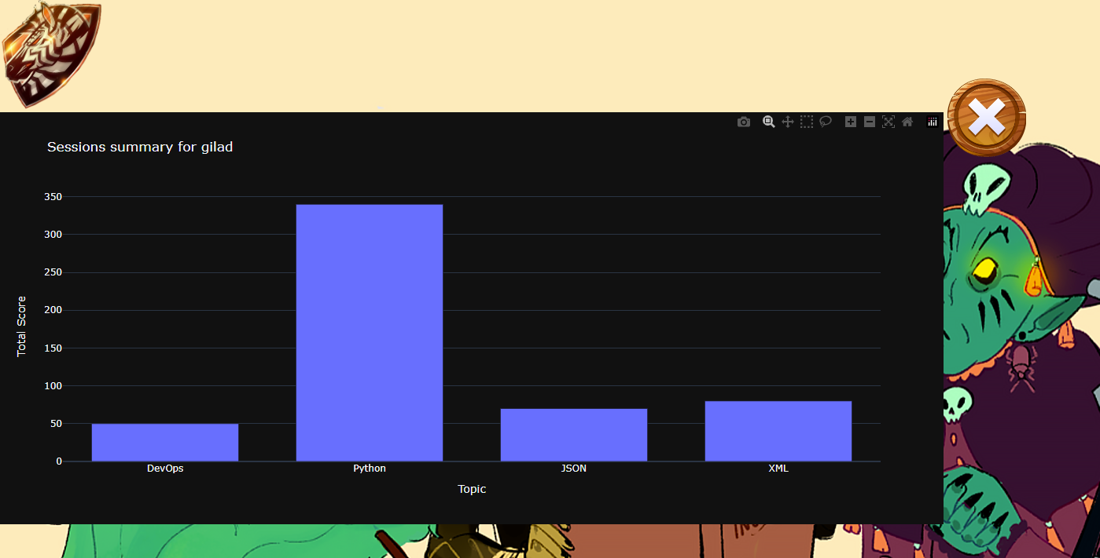

* Question mark screen - takes the player to our lore page that details the game in its pictorial aspect. Pressing the "x" returns to the home screen.

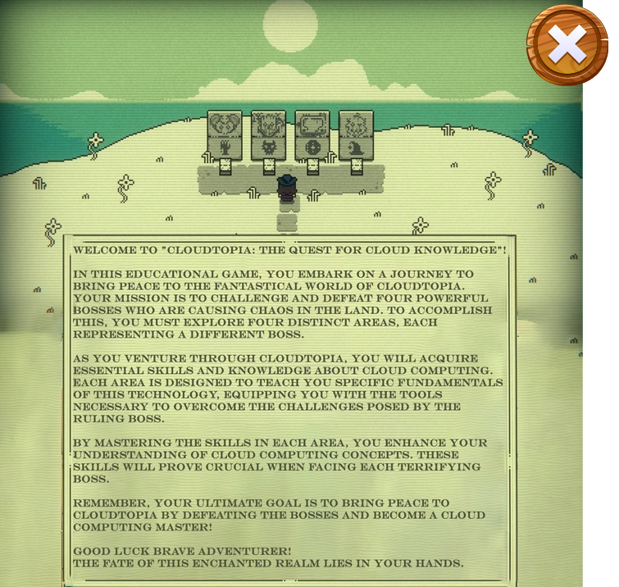

* The quiz map screen – appears after clicking "Play" on the home screen. When you start a game, a transition occurs to our map screen which depicts the four types of quizzes as four corresponding areas on a special map (to illustrate a Quest style game). In the middle of the map there is an area that allows you to view an explanation of the game (according to the lore page). In addition, there is a button to return to the main screen (home) and a button to watch a credit video of the creators of the project.

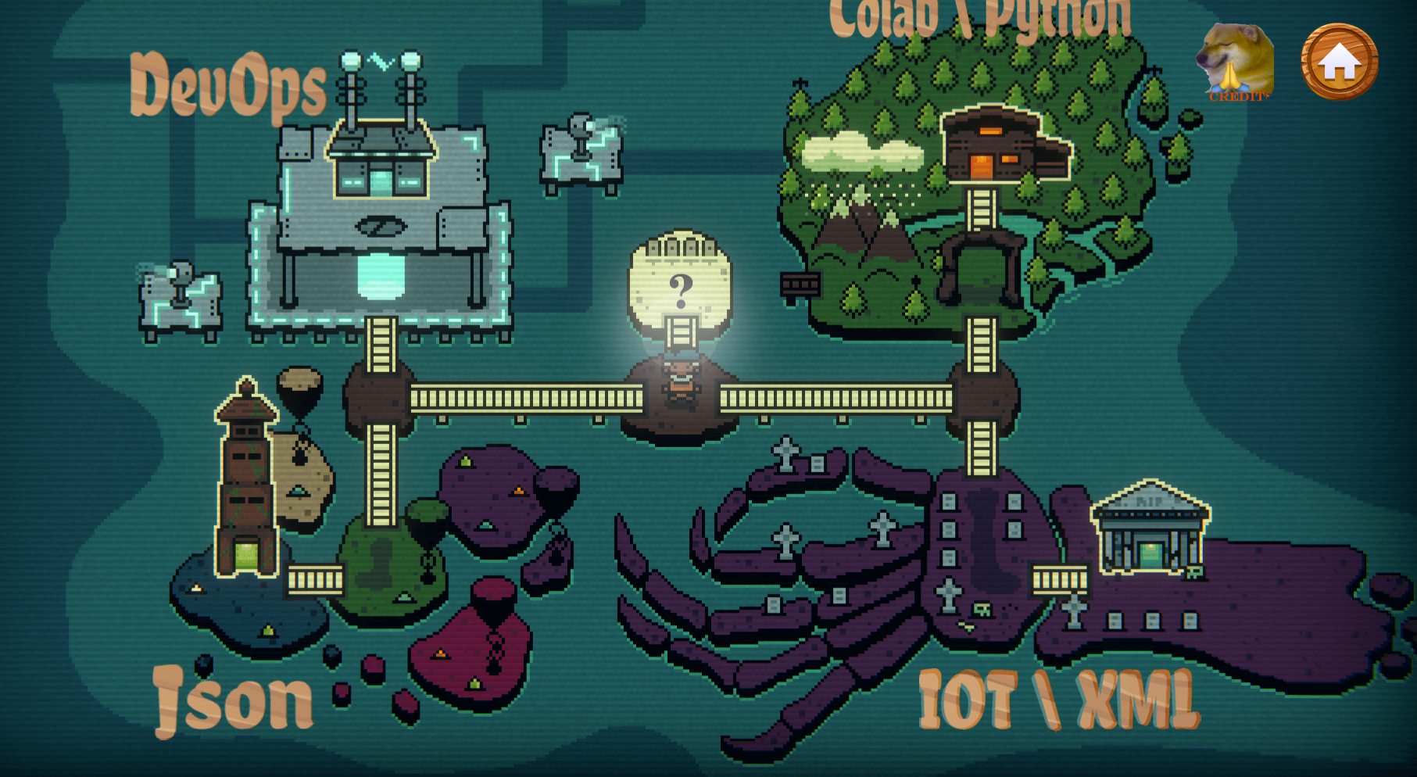

* The quiz screen - after clicking on a certain area on the quiz map, the user goes to the start of the quiz screen when a message from the current boss (that represents that area) appears. After that, the game starts in the form of trivia questions as described earlier. For each type of quiz there is a unique design and a unique melody style that enhances the atmosphere of the game. You can also modify the sound level of the music as you like.

Message Screen in XML quiz:

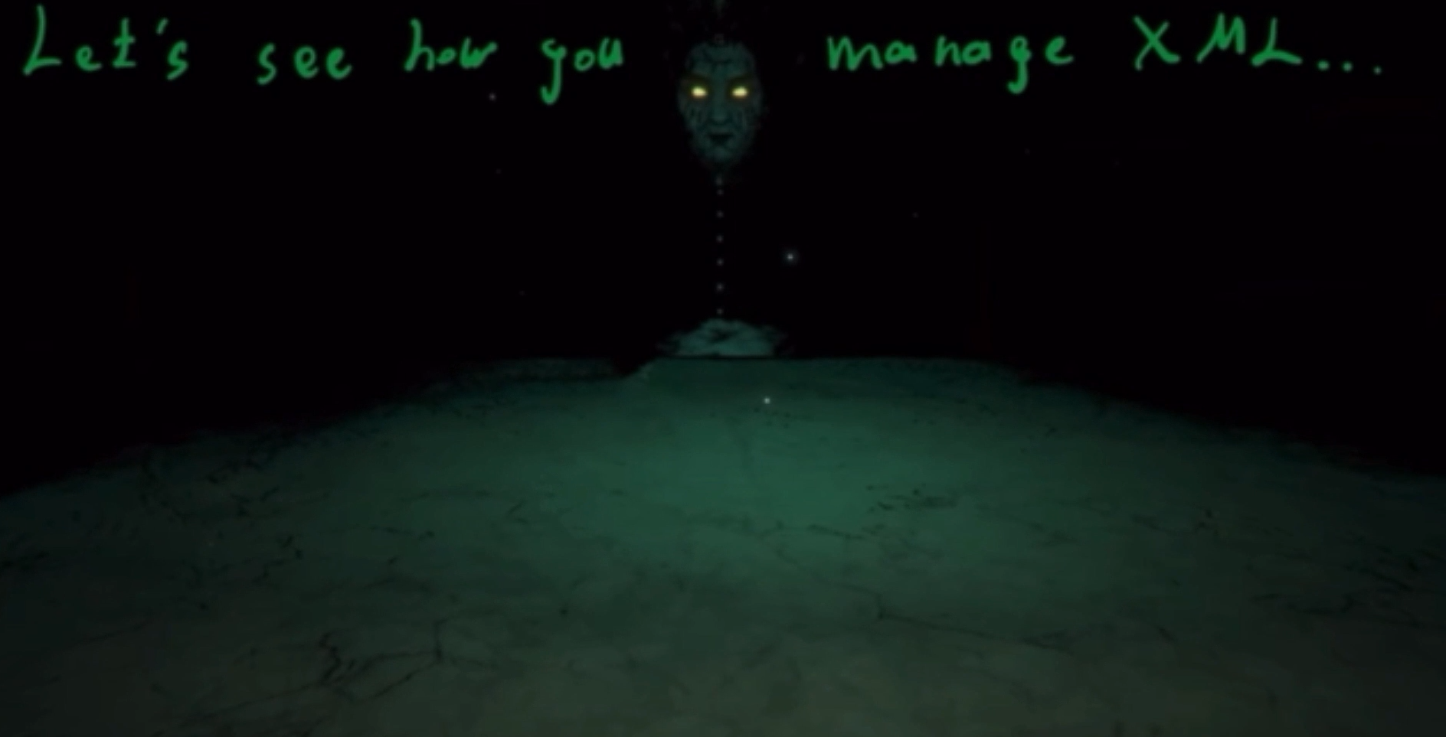

Question Screen in XML quiz:

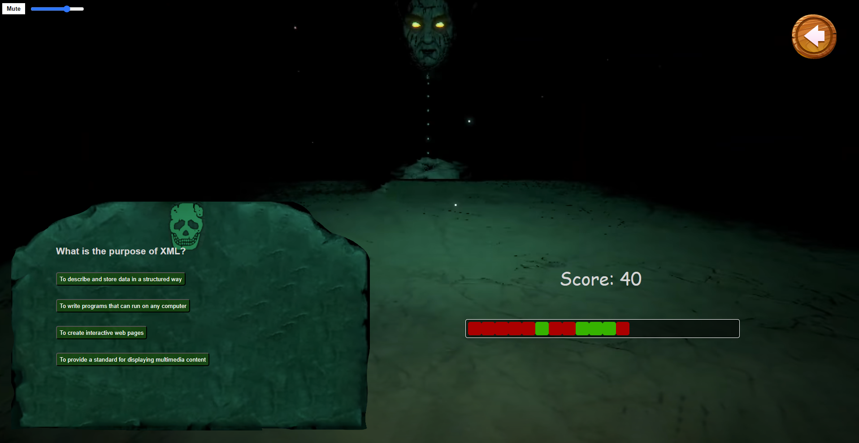

Message Screen in Python quiz:

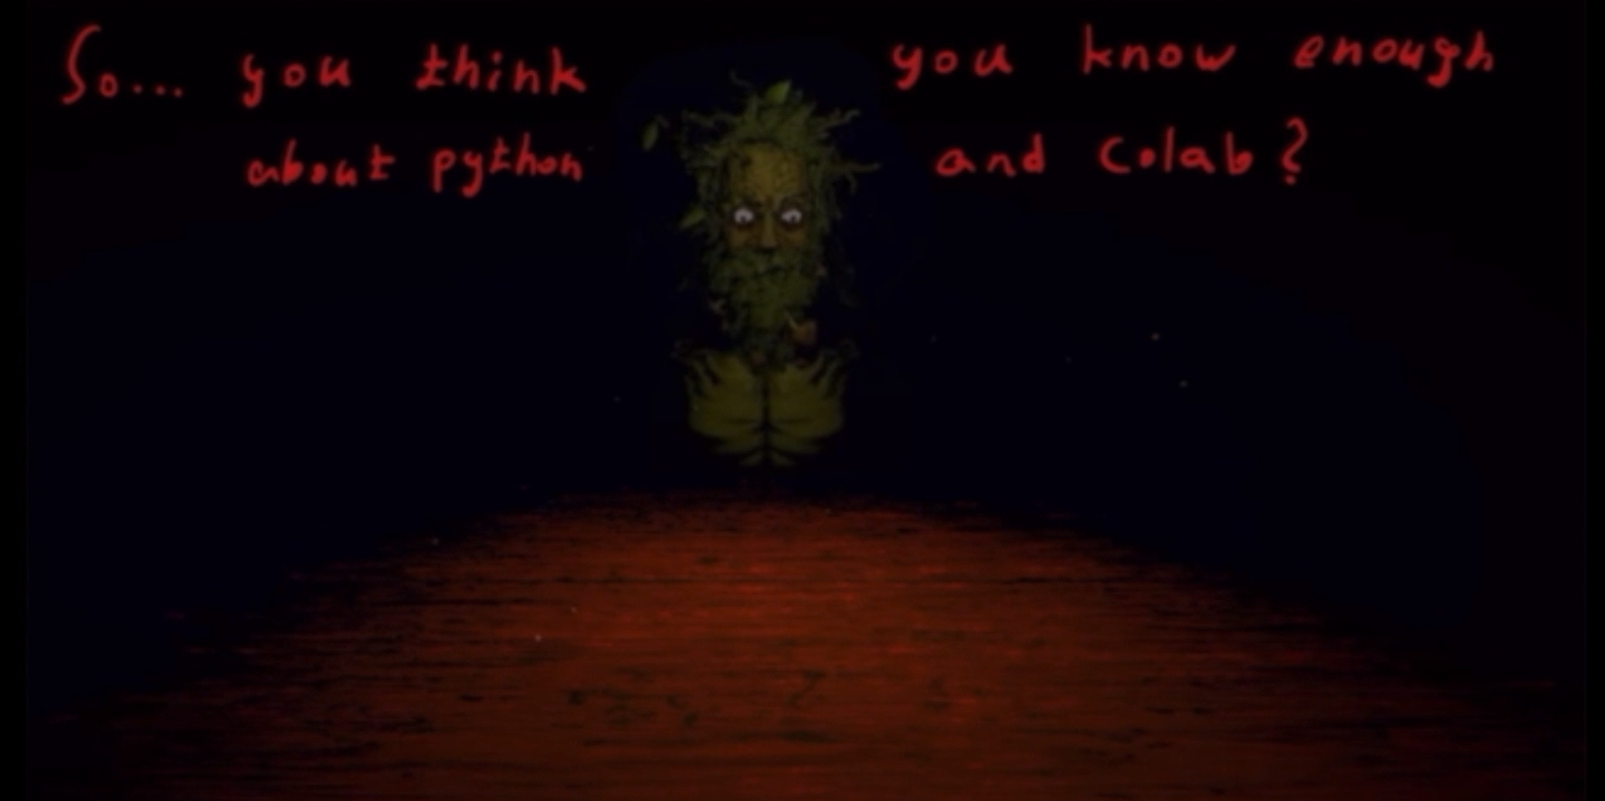

Question Screen in Python quiz:

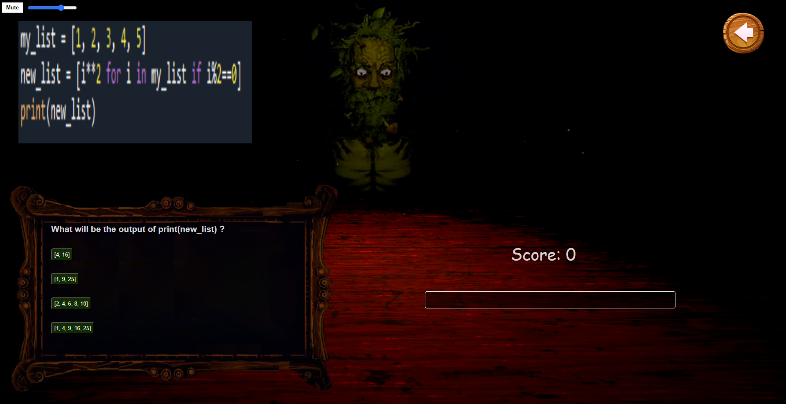

Message Screen for DevOps quiz:

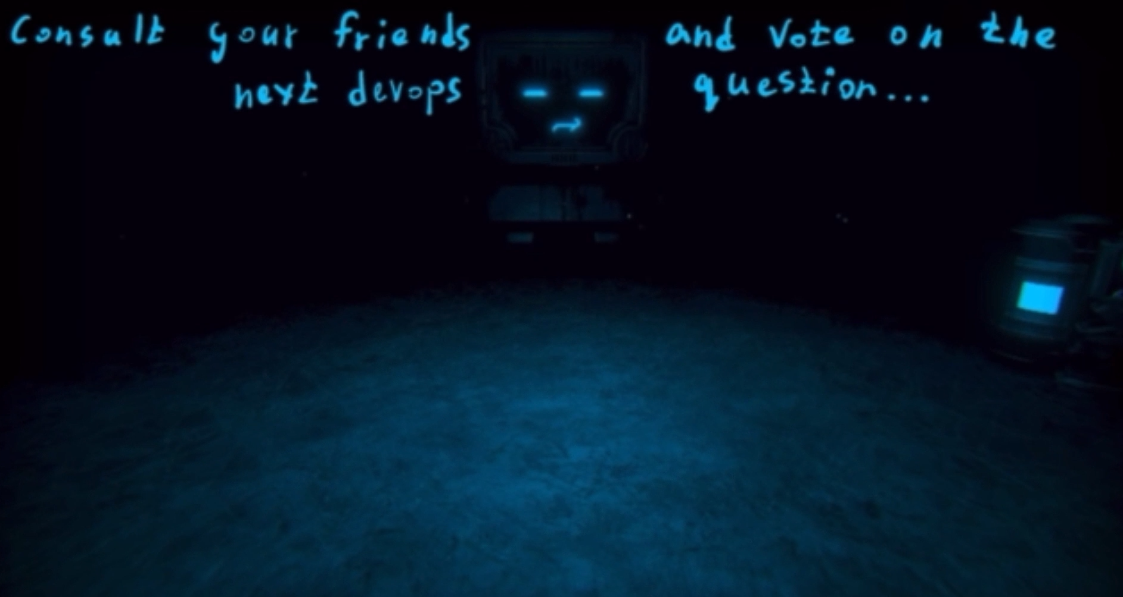

Question Screen in DevOps quiz:

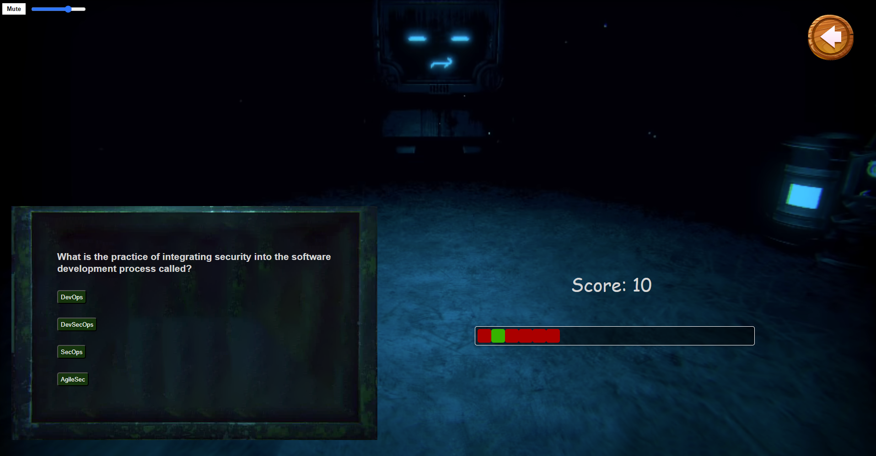

Message Screen in Json quiz:

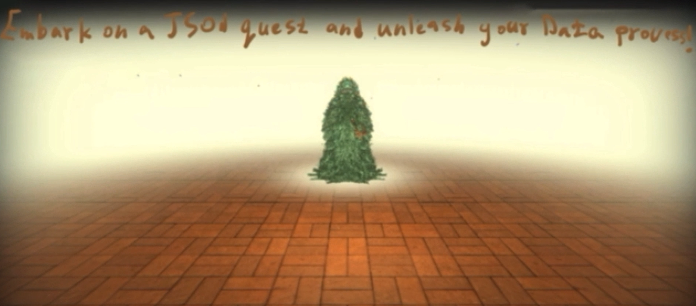

Question Screen in Json quiz:

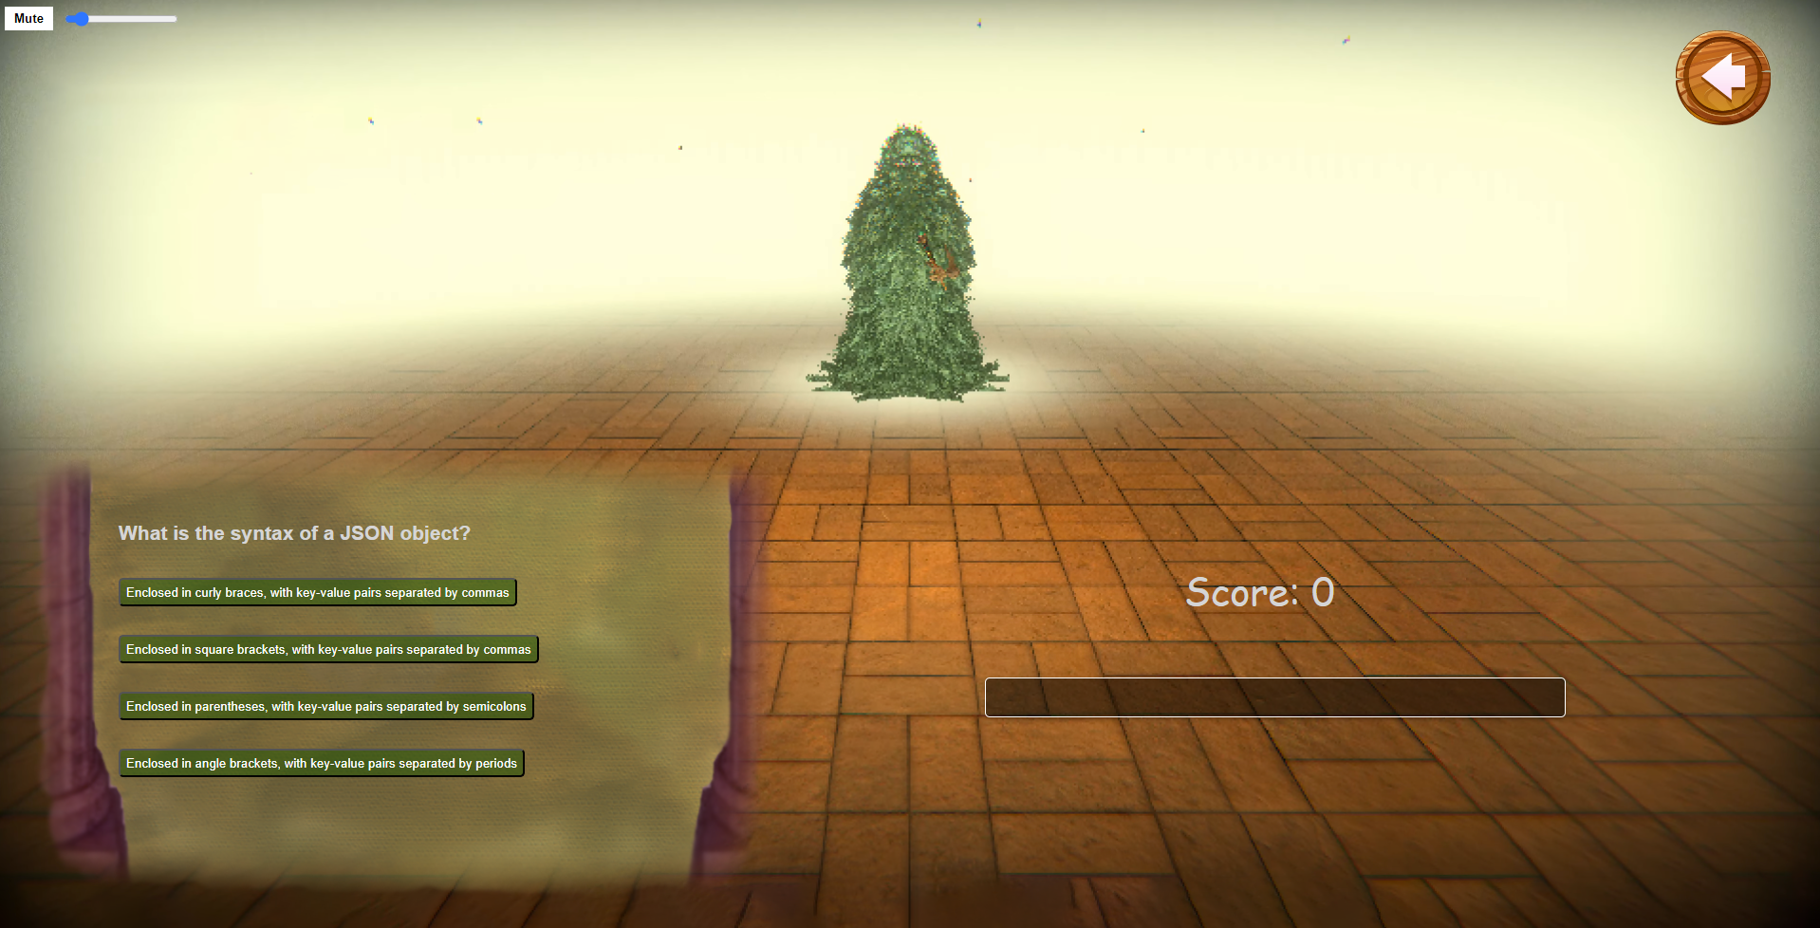

Correct answer indicator - when choosing a correct answer, a positive message will appear to the user and the Progress Bar will be updated accordingly.

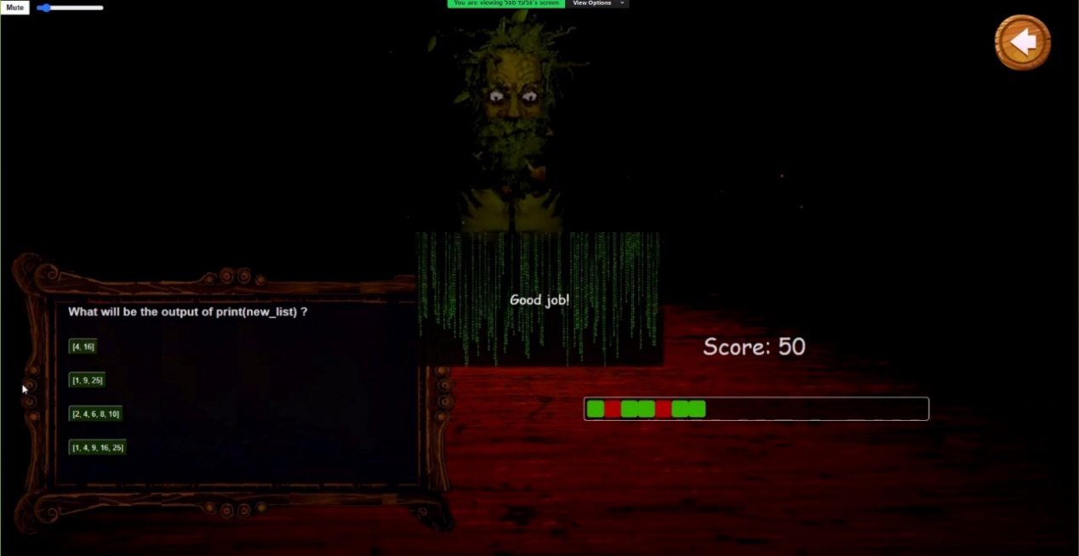

Incorrect answer indicator - when choosing an incorrect answer, a negative message will appear to the user and the Progress Bar will be updated accordingly.

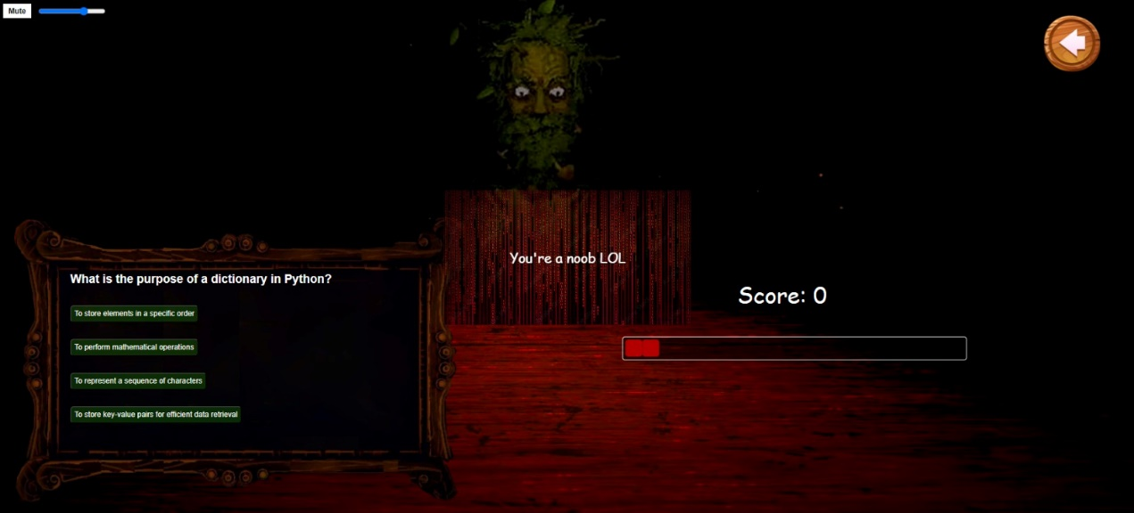

* Game summary screen – at the end of 20 questions of a certain quiz, a graph is displayed, summarizing the results of the user in the game he was playing.

Python results summary screen divided into 4 sub-topics: Structure, Syntax, Concepts and Semantics, Logic.

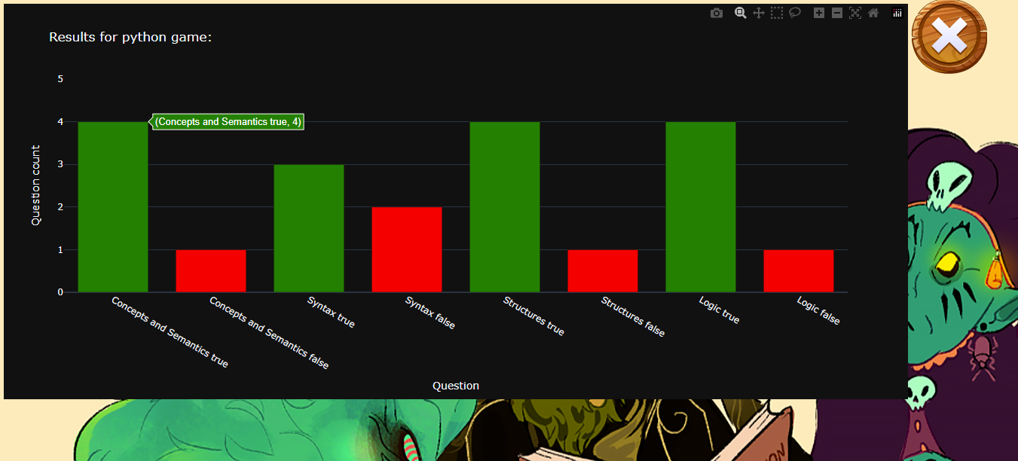

XML results summary screen divided into 4 sub-topics: Parsing, XML Elements and Attributes Syntax, Introduction.

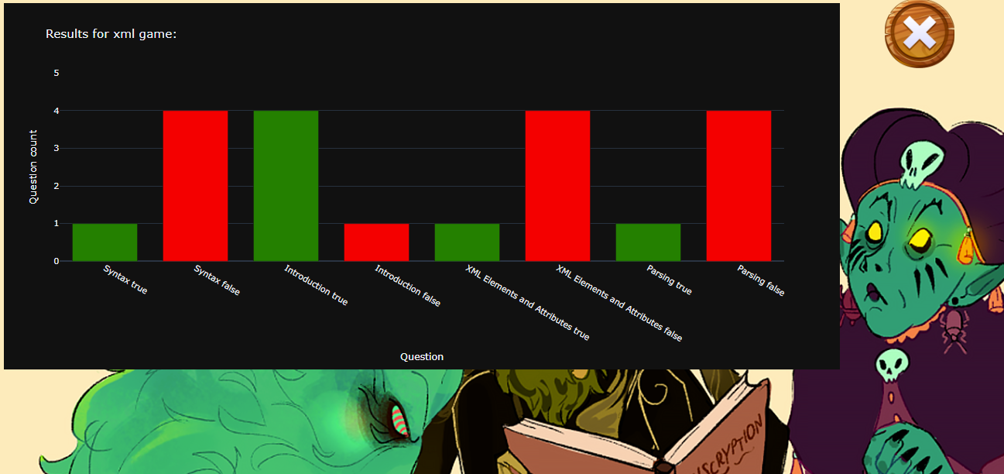

DevOps results summary screen divided into 4 sub-topics: Monitoring and Altering, Infrastructure as Code, Continuous Integration and Deployment, Security in DevOps.

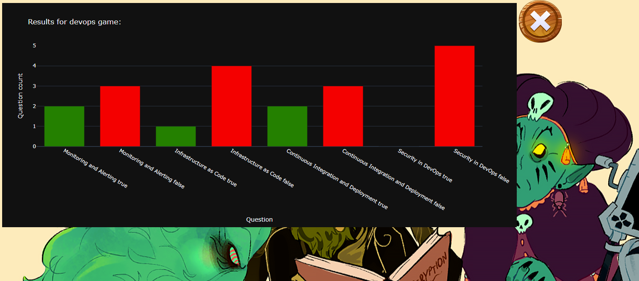

Json results summery screen divided into 4 sub-topics: Usage, Syntax, Manipulation, Parsing.

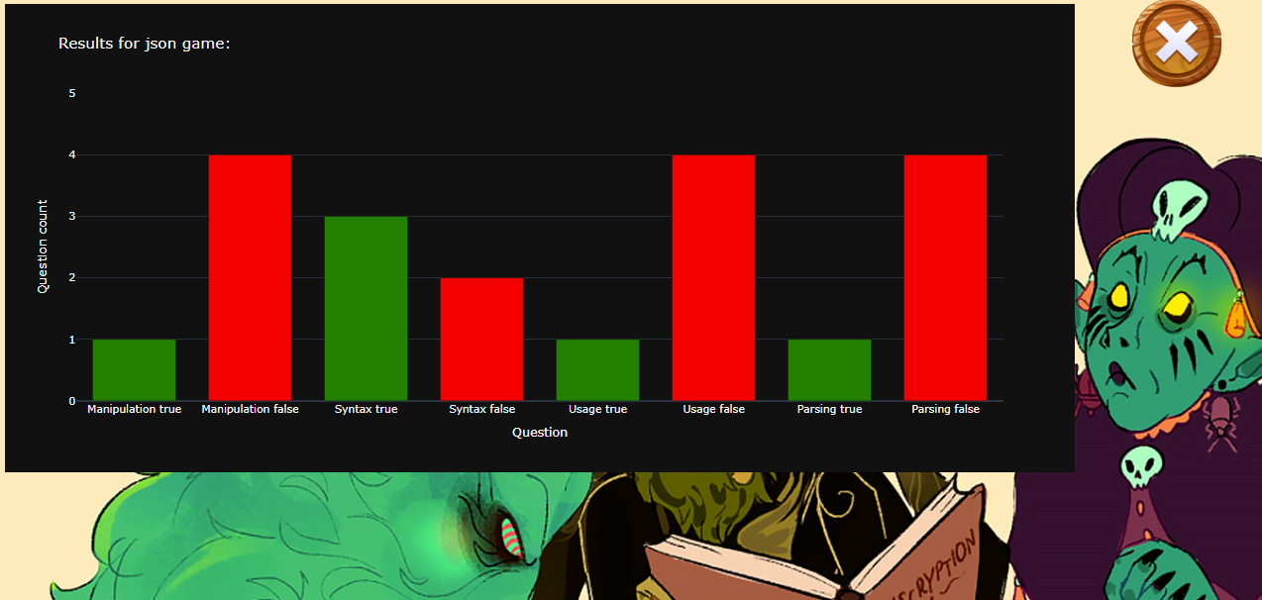

Credits Screen (video)



**Screen Details for Admin UI**

* Main screen for the admin - allows the admin to perform several actions as an administrator: adding a new question, updating an existing question, deleting an existing question, adding a new user, updating an existing user's details, and deleting an existing user.

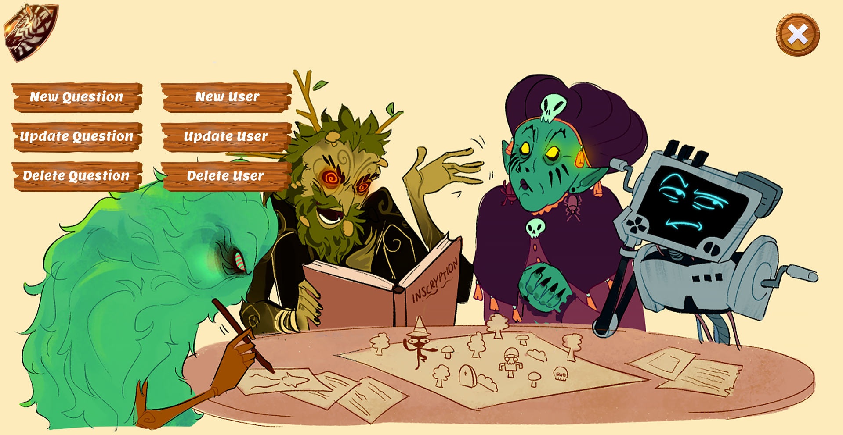

* Add a new question screen – displays a form to be filled out by the admin for the question details: title, question topic, answers, correct answer, question level and question type.

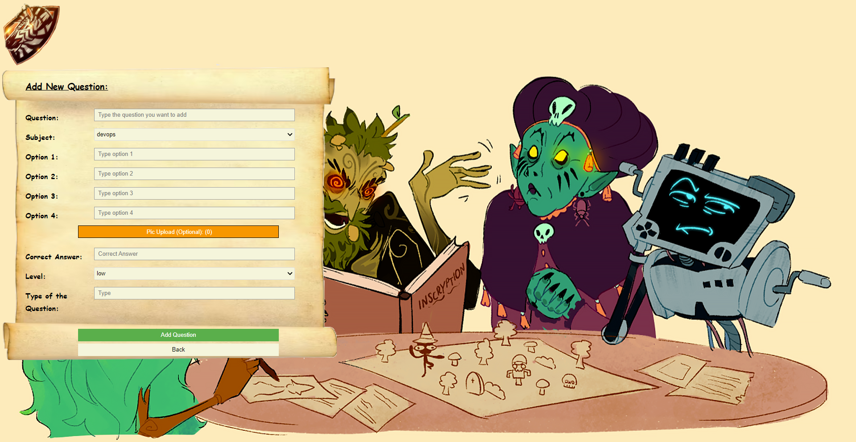

* Screen for updating an existing question - displays a form to be filled out by the administrator for the question details to be updated according to the question title: title, question subject, answers, correct answer, question level and question type.

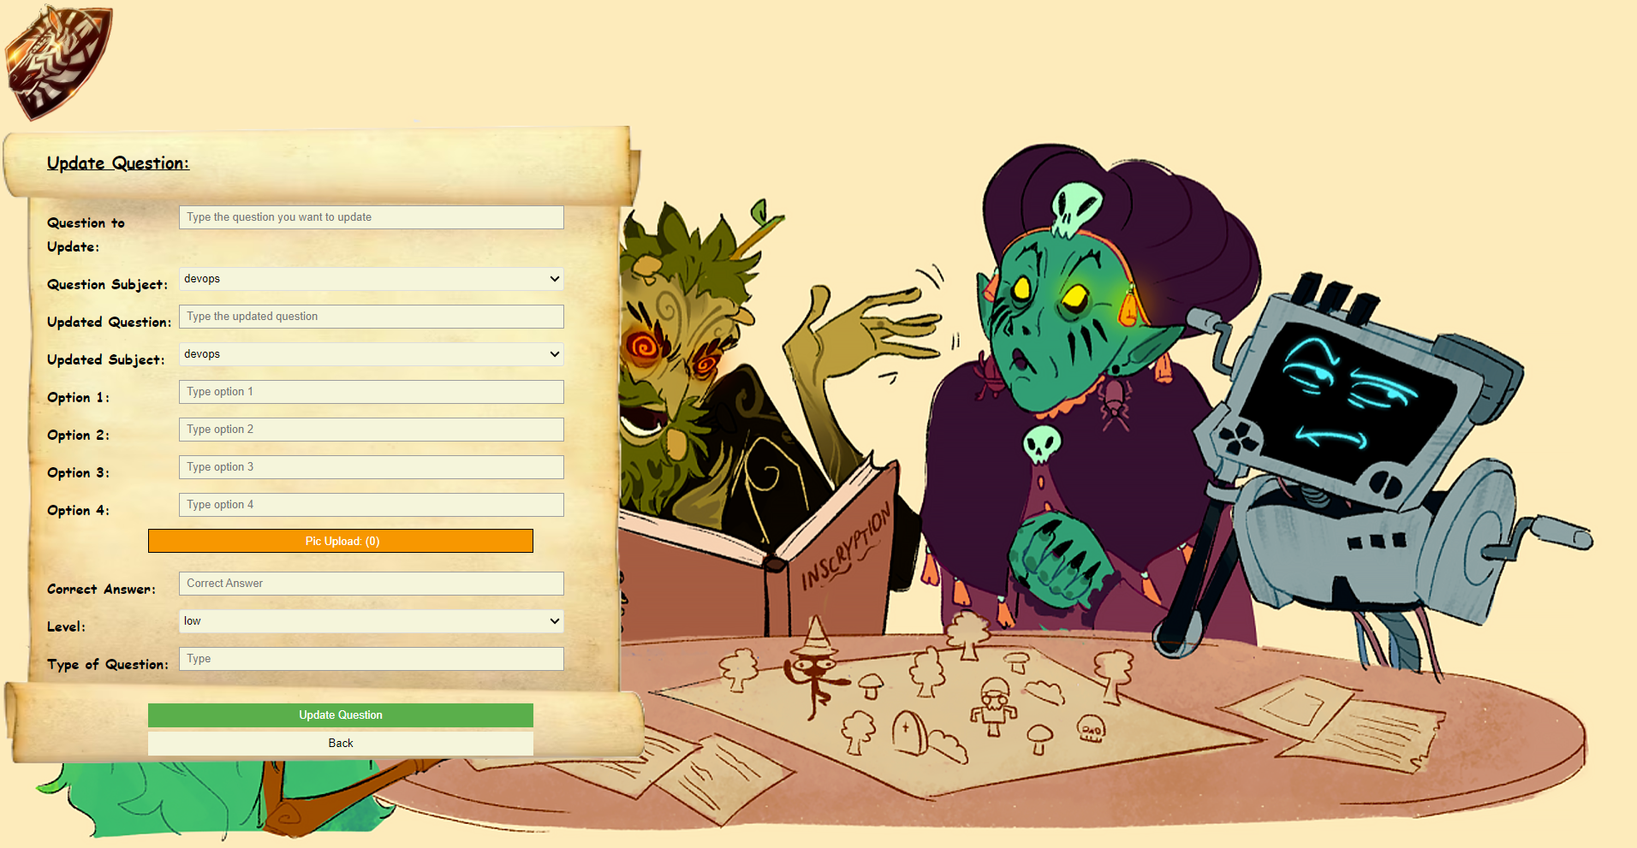

* Screen for deleting an existing question - displays a form to be filled out by the admin in the context of deleting a question (according to the title of the question and the type to which it belongs).

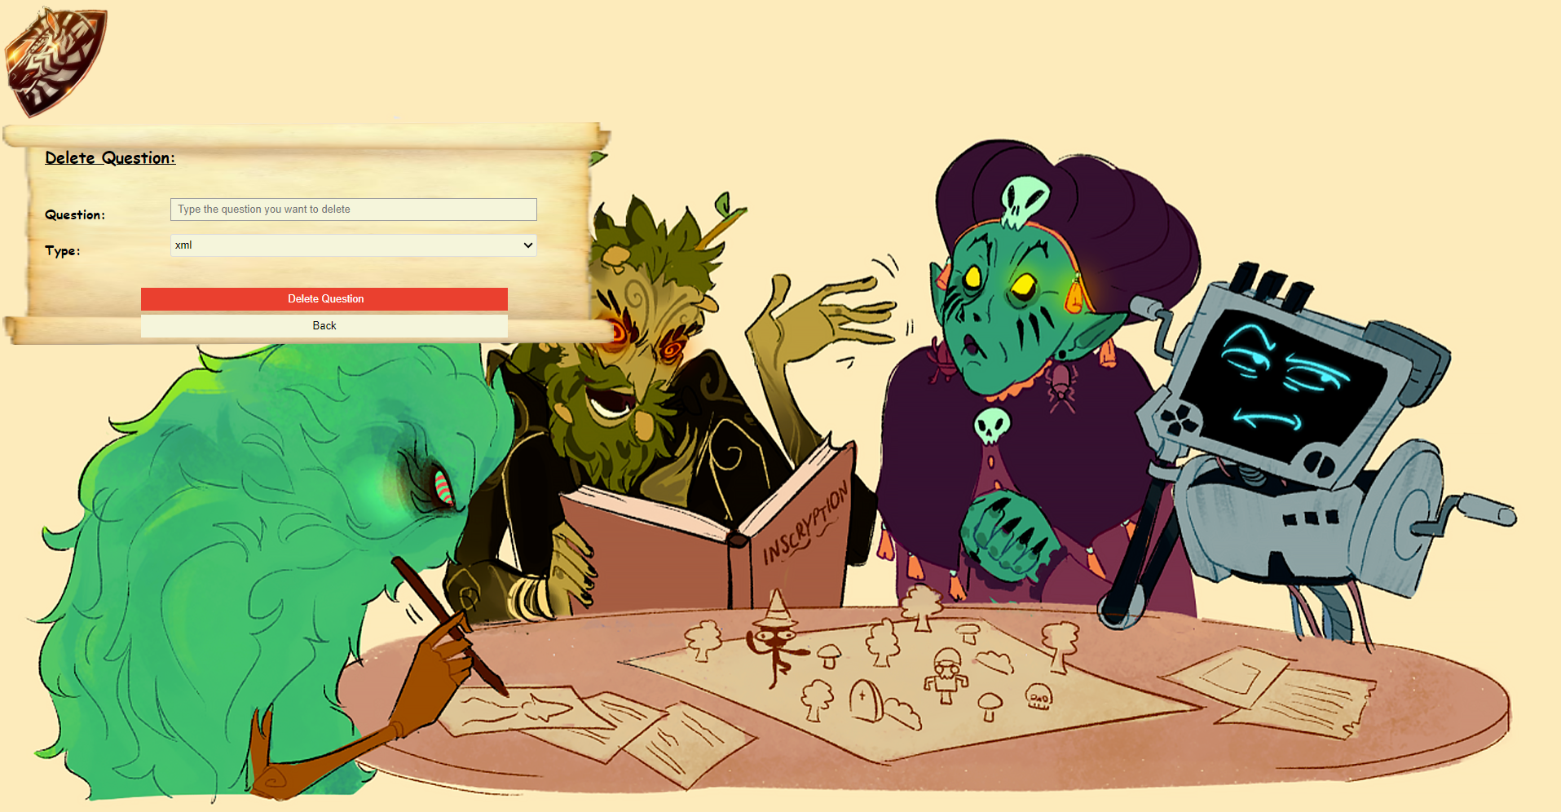

* Add a new user screen - displays a form to be filled out by the admin for the user's information: username, password and whether defined as an admin.

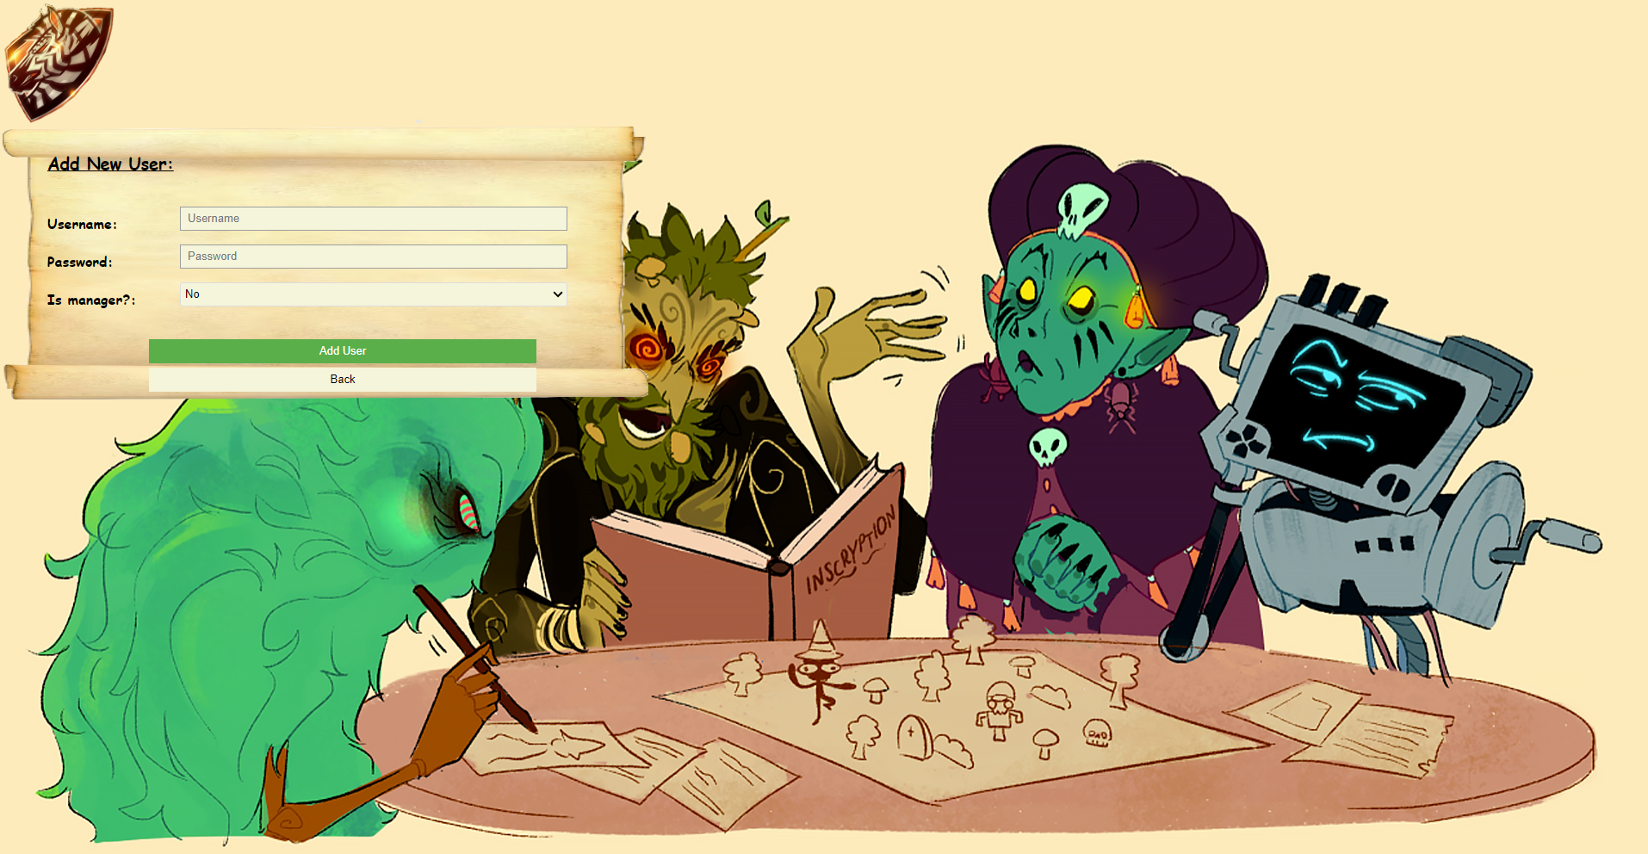

* Existing user update screen - displays a form to be filled out by the admin. The admin enters an existing username (used for identification) and the player's new details.

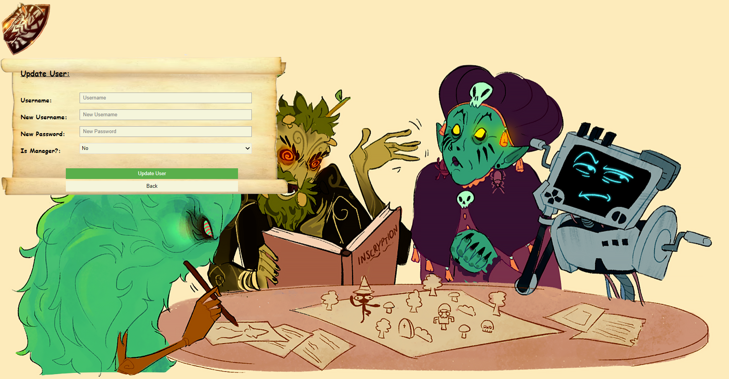

* Screen for deleting an existing user - displays a form to be filled out by the admin. The admin enters the user's information to delete it from the database.

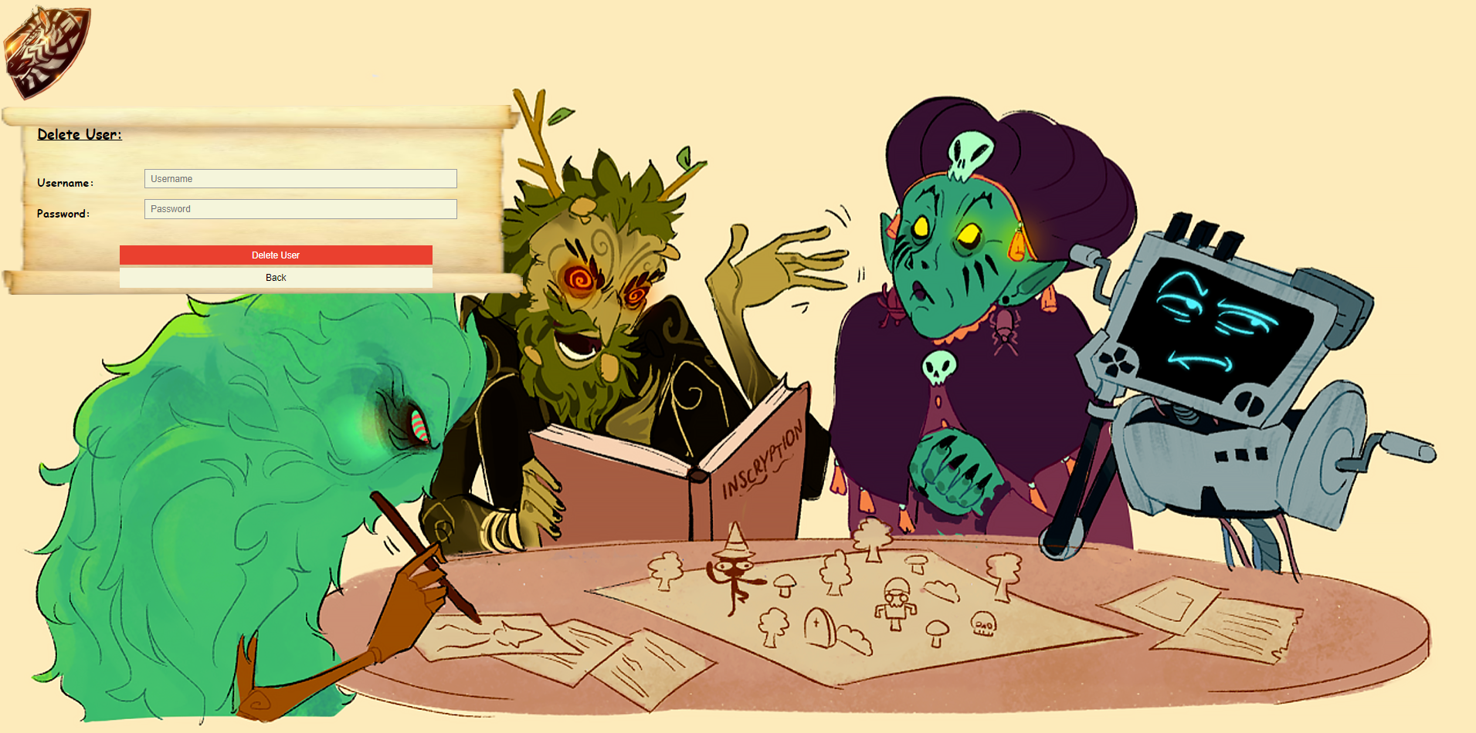

**Possible Errors**

* Login logic - there is no deep check of prohibited regular expressions when entering login information into the system.
* Exiting the quiz before it has ended does not lead to the presentation of a graph of the player's results for the questions he answered in the quiz (until that point).
* Logic of admin actions - lack of checking that a user/question exists in the system before performing an action.

**Future Options for our Project**

At a late stage of the project, it will be possible to use different levels of difficulty (which already exist in the database but isn't used game-wise), solving more advanced problems, implementing advanced services in the cloud such as cloud computing, information security and more.

The general idea is that during the game the players will be able to use the skills and knowledge they have gained to solve puzzles and fight bosses in different levels. Also, another idea is to create cooperation with other players to compete with them or join as a group to solve common tasks.

1. **אתגרים במהלך הפרויקט**

* במהלך הפרויקט היינו צריכים לעבוד יחד כצוות ולחלק את העבודה כך שאף חבר צוות לא ירגיש מקופח. כל אחד מאיתנו היה מעוניין לתרום כמה שיותר כדי להביא להצלחת הפרויקט.
* בכמה הזדמנויות נאלצנו להתפשר אחד עם השני על רעיונות או נושאים שרובנו לא קיבלנו. במקרה בו היינו צריכים לקבל החלטה בנוגע לסוגיה מסוימת, היינו מדברים עליה בפורום כלל קבוצתי ושוקלים את היתרונות/חסרונות של אותה החלטה. אם רוב חברי הקבוצה הסכימו על הרעיון אז הוחלט לבצע אותו, אחרת וויתרנו עליו.
* נאלצנו לעשות ויתורים על רעיונות לפיתוח בגלל טווחי זמן קצרים. לעיתים היו רעיונות מעולים שהציעו חברי צוות שונים אך מפאת מסגרות הזמן הקצרות להשלמת מטלות שונות (יחד עם שאר חובותינו האקדמיות) נאלצנו לזנוח רעיונות אלו.
* היינו צריכים לעשות שינויים במבנה הקבוצה שלנו ולהסתגל לאירועים פתאומיים שהשפיעו על הקבוצה שלנו כולה.